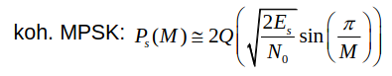
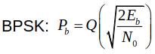
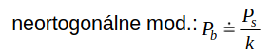
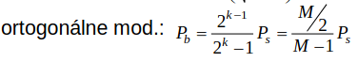
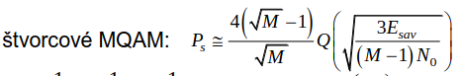

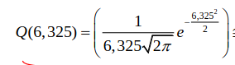
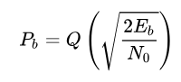Figure 1: 2Q(...)

